**Assignment 2 with script**

**Script –**

pipeline {

agent{

label{

label 'built-in'

customWorkspace'/root/target'

}

}

tools {

maven 'apache-maven-3.9.9'

}

stages{

stage('one'){

steps{

git branch: 'master' , url: "https://github.com/Shantanumajan6/project.git"

sh" mvn clean install "

sh '''

sudo chmod 400 /root/linux.pem

sudo scp -i /root/linux.pem /root/target/target/LoginWebApp.war ec2-user@13.233.37.99:/home/ec2-user/apache-tomcat-10.1.40/webapps

'''

}

}

}

}

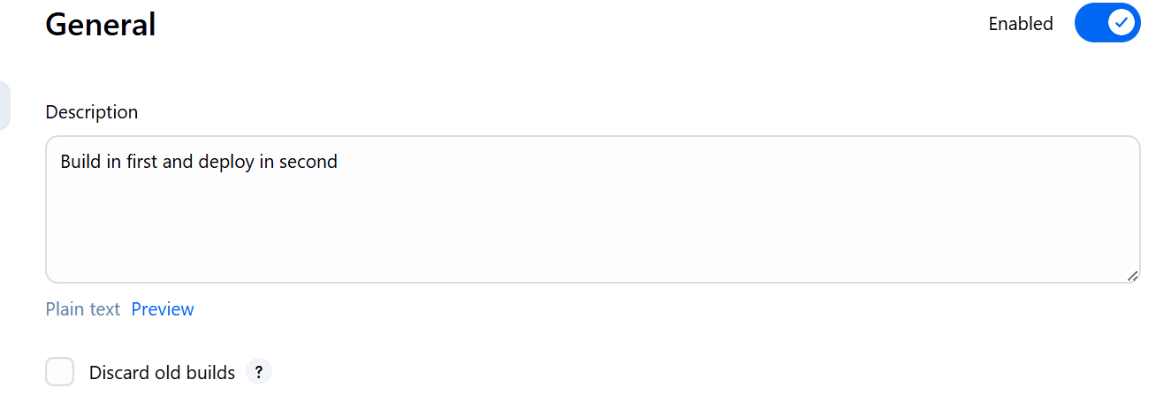

**Console outputs –**

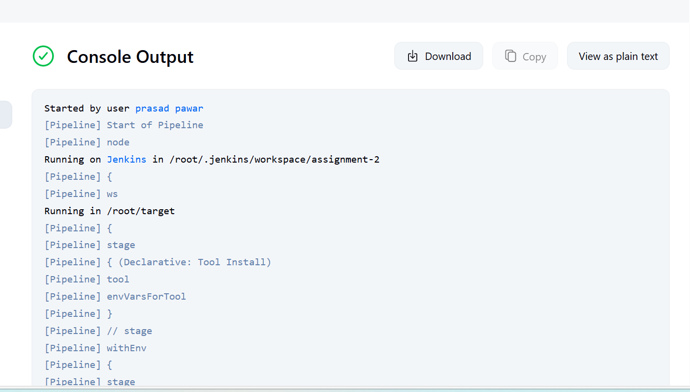

**Final Result –**

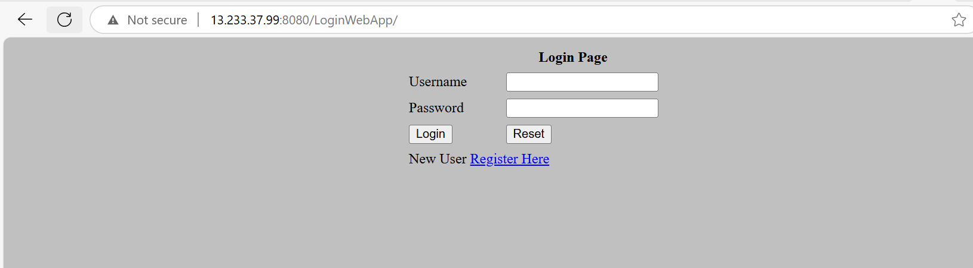

**Instance Info –**

